Checking the Final Exam result and diploma qualification in Neptun

The results will be sent to the Study Department after the answer of the last final examiner of the committee. The recording of the results will be done no later than 12:00 (noon) of the day after the final exam.

The steps to view the final exam result are as follows:

Enter Neptune, select the Final Exams submenu from the Administration menu.

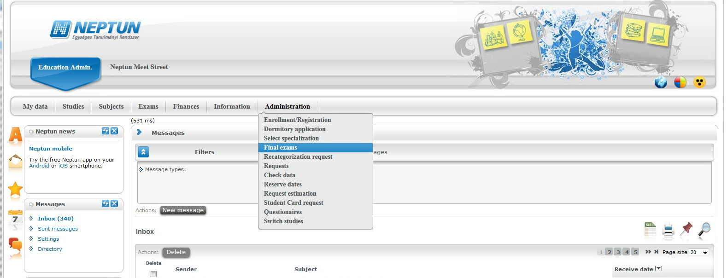

At 2021. June final exam period click on the + sign in the grey part and then on „Details”.

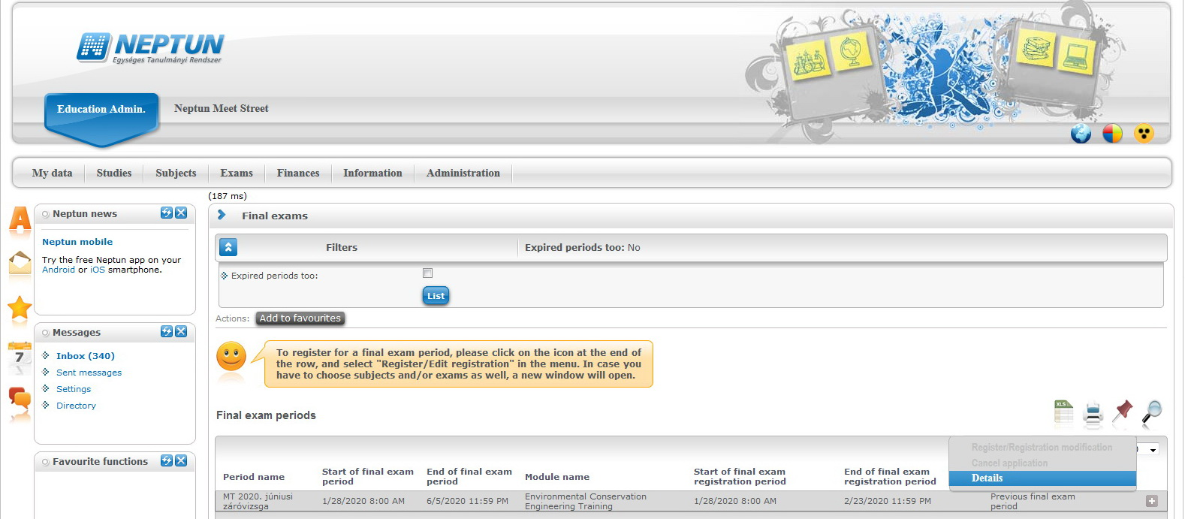

Put a tick next to the „Only taken exams”, thus you will see the completed exams and their results.
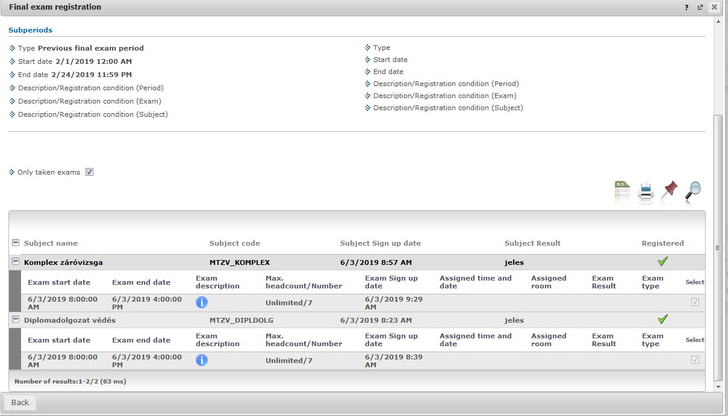

The steps of checking your diploma qualification:
In Neptun click on Studies and then Training data.
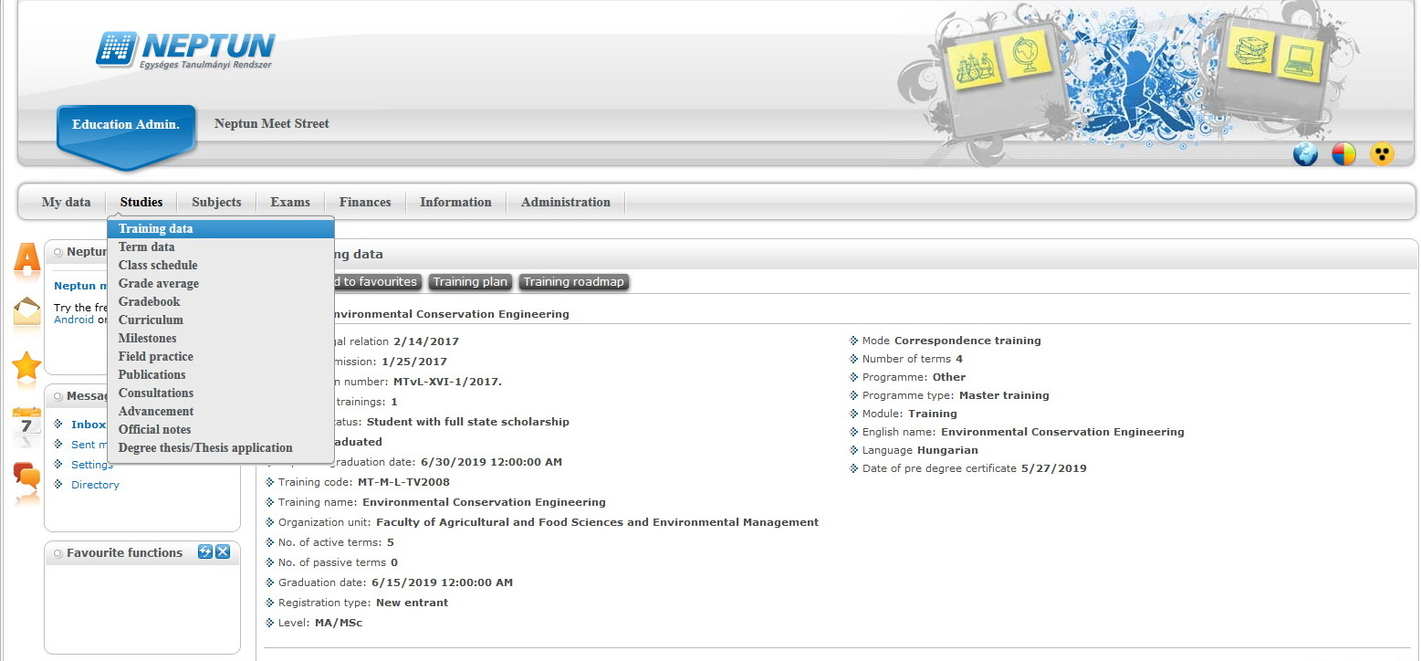

Scroll down a bit and you will see the qualification of your diploma in text and to two decimal places.
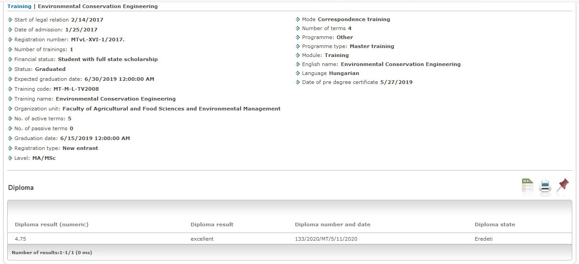

Congratulations to your final exam!

