University professor
Dr. L. Csaba Marton
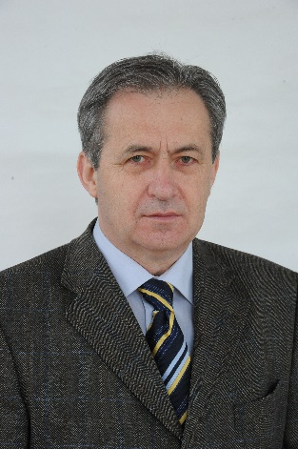
Personal data

Date of birth: Sajószentpéter, 24.02.1954
Mother’s maiden name: Mária Inklovics
Address: 3400 Mezőkövesd, Klementina út 2.

Educational qualifications:

1981 University of Agricultural Sciences, Gödöllő, certified genetic engineer of agriculture
1978 University of Agricultural Sciences, Debrecen, certified agricultural engineer
Scientific degree:

2004 Doctor of the Hungarian Academy of Sciences (DSc) (23/04/2004)
Title of the DSc dissertation: Yield, growing time and stalk strength of maize hybrids
2000 University of Debrecen, habilitated university professor
1992 Candidate of Agricultural Science
Title of the dissertation: Cold tolerance of inbred maize strains and their hybrids
1984 PhD, University of Agricultural Sciences, Gödöllő

Scientific data:

Journal article: 339
Book excerpt: 149
Conference publications: 100
Total number of citations: 593
Number of independent citations: 378
Hungarian patent/protection: 300
International patent/protection: 102

Workplaces:
1978- Agricultural Research Institute of the Hungarian Academy of Sciences, Martonvásár, and since 2012 its legal successor, the Agricultural Institute of the Agricultural Research Center of the Hungarian Academy of Sciences, Martonvásár.
2016- University of Debrecen, Faculty of Agricultural and Food Sciences and Environmental Engineering (DE MÉK)

Title, research area and language skills:

Title

1978-1980 junior research fellow HAS Agricultural Research Institute
1981-1987 research fellow HAS Agricultural Research Institute
1987-2004 scientific head of department HAS Agricultural Research Institute
2004-2012 deputy director of science HAS Agricultural Research Institute
2012- scientific head of department HAS Agricultural Research Institute
Maize breeding department
2016- university professor DE MÉK

Research field

Maize breeding. Improving the resistance of maize to biotic and abiotic stress and other important agronomic properties through breeding. Our research results have contributed to the creation of cold-tolerant, early-maturing, fast-releasing, solid-stemmed, disease- and pest-resistant genotypes that are tolerant of the expected effects of climate change.
As a result of the research, 402 intellectual products (state-certified variety and patents) have been produced so far, of which 102 are foreign applications. A group of varieties has also been state-certified in other countries (Belarus, France, Iran, Germany, Italy, Russia, Romania, Slovakia, Turkey, Ukraine). The total sown area of the varieties exceeds 12 million ha.

So far, I have been involved in the development of more than 20 research proposals.

Language skills
Russian type C, state intermediate language exam (1979)
English type C, state intermediate language exam (1981)
IT skills
User level skills of MS Office

Longer study trips, scholarships, recognitions:

Year 1981 2 months VSZGI, Odessa
Year 1983-84 5 month NAS, Iowa State University, USA
Year 1985 2 month INRA France
Year 1987 2 month INRA France

Professional recognitions:

Academic Youth Award 1984
Academic Patent Award (2007),
Fleischmann Rudolf Prize (2015),
Jedlik Ányos Prize (2016).

Membership in the editorial board of scientific journals:

2015- Kukuruza i Sorgo, Russian scientific journal

Scientific membership and functions:

1989-1994 FAO Fusarium Subnetwork - coordinator
1993-2000 GATE (SZIU), Doctoral Committee, Special Board of Crop Sciences
2006-2015 GATE (SZIU), University Doctoral and Habilitation Committee
1996- HAS Crop Breeding Committee, member
2007-2011 President of the Hungarian Plant Breeders Association,
1988- EUCARPIA, member
2006-2009: EUCARPIA Corn and Sorghum Section, President
2004-20015 EUCARPIA national representative
2014- University of Debrecen, Kálmán Kerpely Doctoral School core member

Supervising the scientific work of young researchers, participating in doctoral training:

Graduated PhD students:

Emese Nagy 2004 PhD
Csaba Szőke 2011 PhD
Zsubori Zsuzsanna Tóthné 2011 PhD
Ferenc Endre Rácz 2012 PhD

Martonvásár, 12. October 2020

dr. Lajos Csaba Marton

