Weekly practice

Practice location: Élelmiszeripari Innovációs Központ (Food Industry Innovation Center)
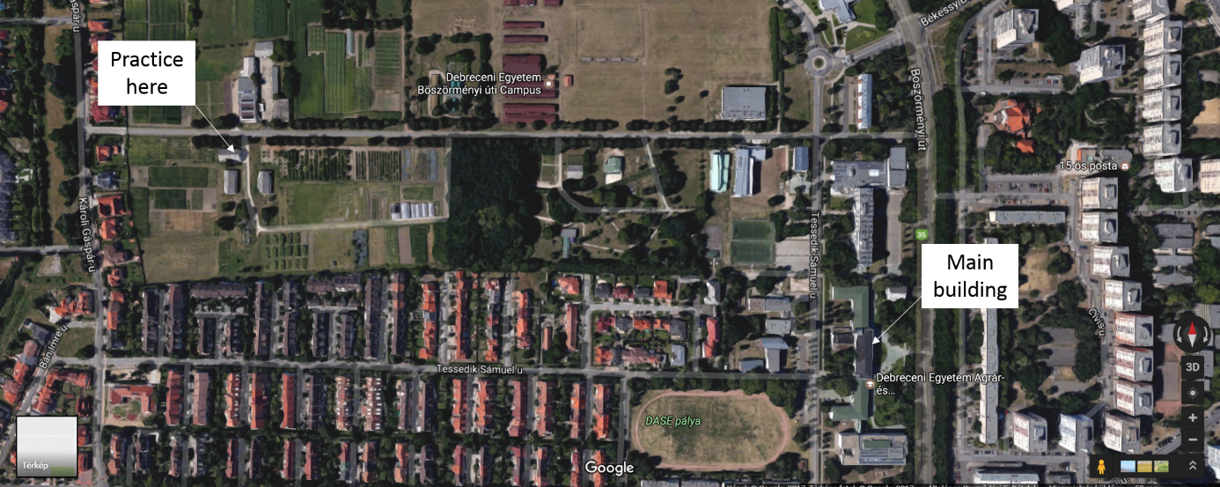
Conditions for participation in practice:
- In Neptune, we announced a special course for each week (starting from the first week of the semester), with a maximum number of 5-8 students per group (no expansion). Everyone should register for the course in which they can participate the week. Attendance in practice is compulsory, therefore, the student cannot attend any other lectures /practices during that week. Everyone calculates this for allowed absenteeism and in case of tests or other issues, please, discuss it with the instructors. Certificate about the participation of the weekly practice can be obtained. There is no possibility of variation between the courses after closing the registration period. If something serious comes up, change your week with one of your classmates’ week. This should be reported to harmati.andrea@agr.unideb.hu. The signature is granted if attendance is positive and the requested report (see later) is submitted.
- Valid Medical book. The medical book can be obtained from any stationery shop – eg: Egyetem sgt 50. Papír House. You have to go to the Lung Filter Station (Debrecen, Jerikó street 21-23. – and ask for an appointment from them. The result will be sent to you later, so you should have it done well in advance, about a month before the weekly practice. The lung screening is valid for 1 year. Together with the lung filter result, you should see the doctor, who will validate the book - she is available every Tuesday between 9-10 a.m. on the ground floor of Veres Péter Dormitory – 138. Böszörményi street. Her name is Dr. Terézia Hatvani).
- It is forbidden to enter the plant in street clothes. We provide workwear for everyone, which is obligatory to wear. If you have a personal problem (e.g.: allergy), please, indicate it before the weekly practice (Takács-Gál Marianna: tgal.marianna@agr.unideb.hu, +36 20 247 2684) and we will discuss it.
- It is forbidden to leave the area of the plant in work clothes!
- During the weekly practice, students may leave the site only with the permission of the supervisor.
- Students may not bring in jewellery, money, mobile phones, or any foreign material into the area of the plant units. Leave them in the lockers.
- During the practice we kindly ask you not to wear heavy make-up, artificial lashes and artificial nails.
- Students can stay only in the unit, where the practice is taking place. Moving across the plant units is not permitted.
- Before the weekly practice (Monday 8-10 a.m.) students are trained in accident prevention, hygiene and occupational safety and are required to sign the report on this.
- Students are required to accept and adhere to the instructions of the supervisor during the weekly practice.
- Damage to the tools or equipment must be compensated by the person who caused the damage.
- At the end of the practice, students must leave the area of the plant clean and orderly.
- It is forbidden to remove or take work equipment from the plant.
- Students cannot take the key to the plant with them.
The Weekly Practice Program

2nd year 2019/2020 autumn semester – Processing plant origin products
Monday: 8-10a.m. general briefing, check of medical books, write a small test from the hand-out material with Andrea Harmati
10-16p.m. Vegetable- and fruit processing plant with Andrea Kun-Nemes and Péter Dremák
Tuesday: 8-16p.m. Mill and dry noodle plant with Szintia Jevcsák and Dr. Gerda Diósi
Wednesday: 8-12 p.m. Vegetable- and fruit processing plant with Andrea Kun-Nemes
12-16 p.m. Mill and dry noodle unit with Szintia Jevcsák and Dr. Gerda Diósi
Thursday: 8-16 p.m. Baking plant with Dr. Réka Juhászné Tóth and Dóra Kiss
Friday: 8-16 p.m. Solving individual tasks, creating flowcharts, production sheets and specifications

Submission of assignments: on Friday at the weekly practice.
Each of the submitted documents should have your name, year, program and Neptun code.

3rd year 2019/2020 autumn semester – Processing animal origin products
Monday: 8-9a.m. general briefing, check of medical books, write a small test from the hand-out material with Andrea Harmati
9-16p.m. Meat plant with Dr. László Stündl
Tuesday: 8-16p.m. Meat plant with Dr. László Stündl
Wednesday: 8-16 p.m. Milk plant with Márk Mircz
Thursday: 8-10 a.m. Meat plant with Dr. László Stündl
10-16 p.m. Milk plant with Márk Mircz
Friday: 8-16 p.m. Solving individual tasks, creating flowcharts, production sheets and specifications

Submission of assignments: on Friday of the weekly practice to Máté Szarvas (Building A, 1st floor, room 119.)
Each of the submitted documents should have your name, year, program and Neptun code.

OCCUPATIONAL SAFETY
General information:
- Get ready to work 5 minutes before the scheduled time (without alcohol, drug or other unwanted influence).
- It is FORBIDDEN to smoke in the processing plant or within 5 meters of the building!
- Entry only through women’s and men’s changing rooms.
- Wear work clothes and protective equipment (supervisors will give information). It is FORBIDDEN to enter the units in street wear!
- Jewelleries, mobiles, or other foreign materials may only be taken into the processing unit with the permission of the supervisor.
- Follow the instructions of the supervisor.
- The students may leave the area of the unit during the practice only in justified cases, with the permission of the supervisor.
- Professional use of tools, notification of the supervisor in case of malfunction. Work on the faulty equipment must be stopped. Students must not fix or mend equipment!
- It is FORBIDDEN to do any work that obstructs, interferes with or endangers work!
- The processing facility must be left and closed by the trainee last.
- The work schedule, special occupational safety and accident prevention information for the different operating units will be provided by the supervisors before work is started in the given unit.

The use of electrical equipment and devices:
- Electrical equipment, wires, connectors, switches, hubs, fuses must be disconnected from the mains in case of heat, smoke, damage, failure (repairs may only be carried out by a qualified technician) and the supervisor must be reported about it.

What to do in case of an accident:
- The student must report any accident, minor injury, nausea, work injury immediately to the supervisor.
- The supervisor must take care of the injured person, and, in case of a serious injuries, the supervisor must arrange the preservation of the accident site until the arrival of investigators.

Emergency numbers: 104, 112
When calling you must say:
- What happened, how many injured there are
- The exact location and how it can be approached
- Your name, address and callback phone number

FIRE PROTECTION

General fire protection regulations:
- Burning: reaction of combustible material and oxygen to generate heat accompanied by smoke and / or flame.

- Conditions of burning:
- combustible material
- oxygen necessary for burning
- temperature necessary for burning
- the 3 conditions are present simultaneously in time and space

- Fire: a burning process that endangers or causes damage to life, bodily integrity, or material goods.

Fire alarm:
- The person who detects the fire or its immediate danger must immediately report it.

The toll-free number of the fire brigade: 105, 112
The fire alarm shall include the following:
- the exact location and address of the fire
- what is burning, what is at risk, what damage has happened
- is human life in this danger
- the name of the person and its recallable phone number

Fire extinguishers in the processing building:

- Fire extinguisher (it blocks the oxygen supplying the combustion from the burning material)
- Gas (CO₂) extinguisher (reduces the temperature of the burning material below the ignition temperature)
(The high-pressure outflow of the gas as well as the appliance's outer shell cool down to such an extent (-76 ° C) that it causes frostbite. CO2 is heavier than air and, although not toxic, can cause breathing difficulties above certain concentrations.)

The optimal distance of the fire extinguisher is: cca. 1,5 – 2 m !!!

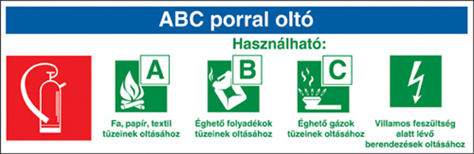

Task in case of fire:
- The person who detects the fire must report it immediately.
- Students start to leave the building immediately when the fire alarm is detected, except those near the fire, and go to the assembly point.
- The assembly point is approx. 100m far, the area next to the road leading to the building.
- Healthy, non-injured students who are not in the vicinity of the fire are obliged to contribute to the extinguishing of the fire at the instruction of the firefighter.

Fire prevention:

- Activities with an open flame on the campus may only be performed with a written permission.

- Switch off electrical equipment or any type of heat generating device, tools or material when leaving the room or they must be brought in a state, which is not dangerous to the environment.

- Doors of the units where persons are MUST NOT be locked.

- In the premises of the building and in the common areas, traffic routes and exits must not be blocked or restricted even temporarily.

- Switches of electrical equipment, fire protection equipment must be kept permanently accessible and safe to use, and they must not be blocked even temporarily.

- Combustible materials must be placed at a distance from electrical equipment so that the equipment does not cause a fire due to malfunction or overheating.

- Do not operate faulty electrical equipment that does not comply with the regulations or is not approved.

- Keep electrical equipment clean and clean regularly of flammable contaminants.

HAZARDOUS WASTE MANAGEMENT

- Animal by-products (hazardous waste) must be collected in a separate container for municipal waste and stored refrigerated until disposed of in a dedicated waste container.

- Disinfect containers after disposal of hazardous waste.

27th August, 2019
László Stündl
responsible for the subject
head of institute associate professor

