Life abroad
I am Lili Tóth, a 4th year agricultural engineering student at the University of Debrecen.
Some information about me: I was a private student in the last year of my high school years, I started college with great fears and anxiety. I was afraid of integration, even though I always thought I could make friends relatively easily. When I was in high school, I was a quiet, retreating student, I wasn’t really open to new things, repeating my daily routine and the usual things provided me with security. It is true that it was already clear to me that I would like to take part in an Erasmus program someday, but I did not think that would happen.
I was a sophomore in college when I went to an Erasmus briefing. I remember that after the briefing was completed along with the experience reports, I already knew: I’ll be in it. That’s how it all started and I can boldly say it was the best decision of my life so far!
Destination: Universitet Rolniczy (Agricultural University of Krakow), Krakow, Poland
Time: September 2018 - February 2019

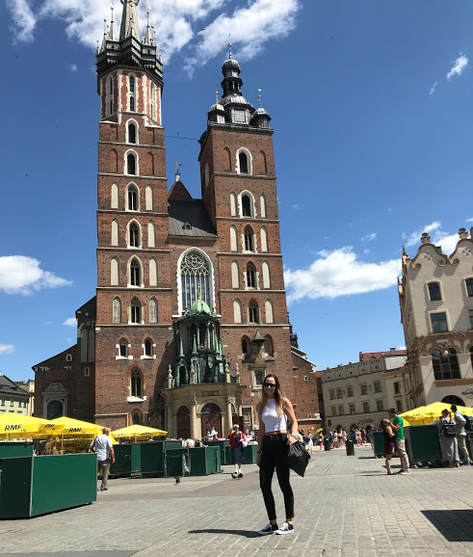
Krakow itself is a charming place, I think anyone who has been there already knows what I am talking about. The extraordinary image of the city is confirmed by the fact that it was declared a UNESCO World Heritage Site in 1978 and has the largest and most spectacular main square in medieval Europe. Here you will find the Church of Mary, the Cloth Hall, one of the most famous palaces on the continent, the Wawel and the Jewish Quarter of Kazimierz.
I would be lying if I said now that everything went smoothly. In the beginning, it was difficult to get used to the customs there, and college life (I was never a college student before), establish relationships, get used to the constant conversation in English. But these difficulties did not last longer than about 2 weeks.

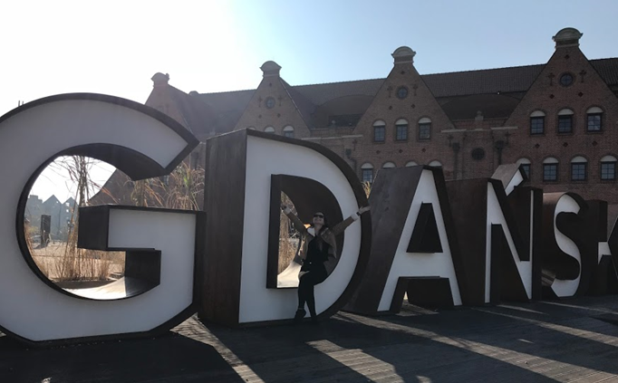
My traveling period soon began, our first destination (along with my new friends) was Gdansk. Gdank is located in northern Poland, on the shores of the Baltic Sea. We left late for the train from Krakow, arrived early in the morning, and after two days here we also left for our own dormitory, Krakow, late at night. It was a perfect first trip!

As we got back, barely a few days had passed and we had already organized the next trip. Of course, I had to go to courses, but luckily it wasn't stressful at all. The lessons were relatively easy to complete, and we received all the guidance and help from the instructors we could need. We mostly had to give presentations instead of taking continuous tests and we could also take part in a field exercise in the second half of the semester. The instructors were also extremely flexible in dealing with possible absences due to travel, and even encouraged us to travel as much as possible, to discover Poland and Europe.
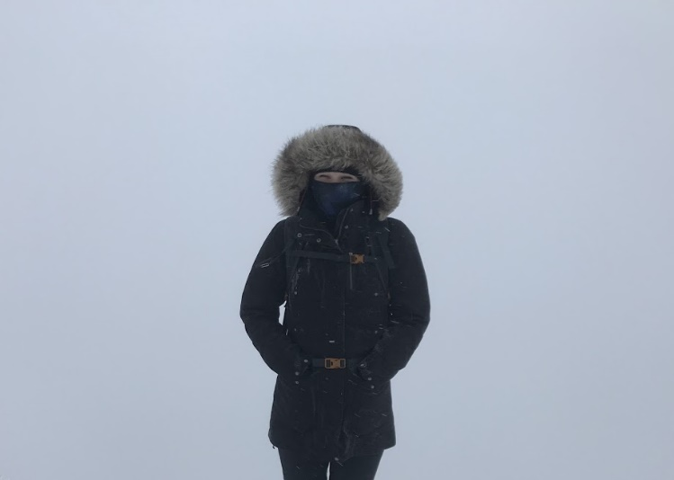
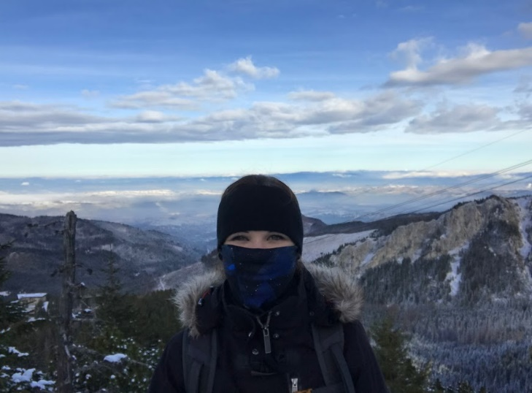
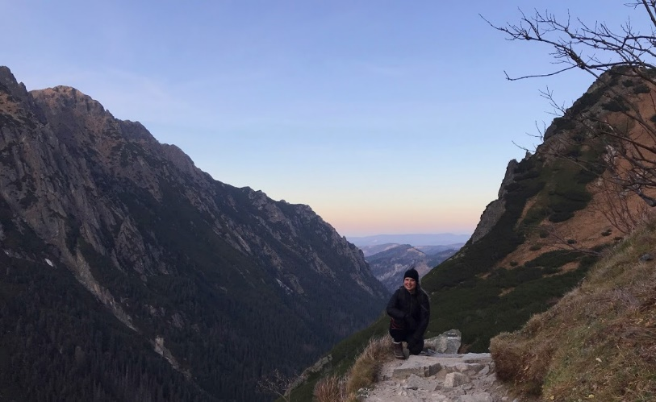
The Tatras (partly due to its proximity) played an important role during our semester. Luckily, our friends all loved hiking, so we never had to find a special occasion for a little climbing. Perhaps I got my most beautiful and fondest memories during the hikes, because when I was standing on the edge of a cliff, on top of a peak or just walking on the ridge and the view of the Tatra Mountains unfolded in front of me, I always felt that everything was perfect. And nature is the most beautiful and the most mysterious thing in the world.

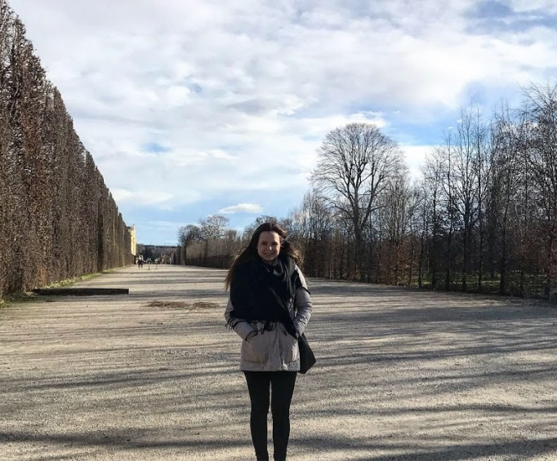
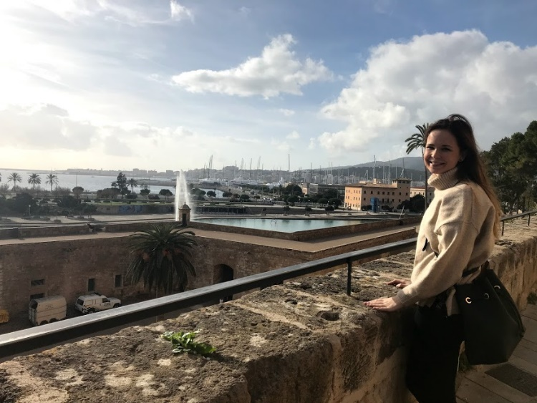
In addition, I had the opportunity to travel to many other places during the semester, e.g. To the Netherlands, Paris, Spain, Vienna, Slovakia and different parts of Poland, and once my family and I visited my Erasmus friends for a few days visit, the Aggtelek Stalactite Cave and the Cave Bath in Miskolctapolca.
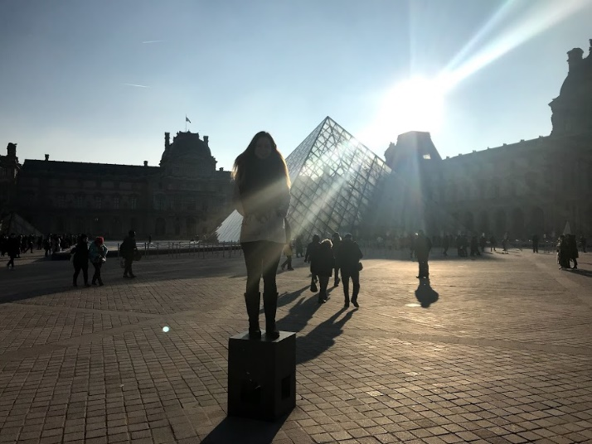
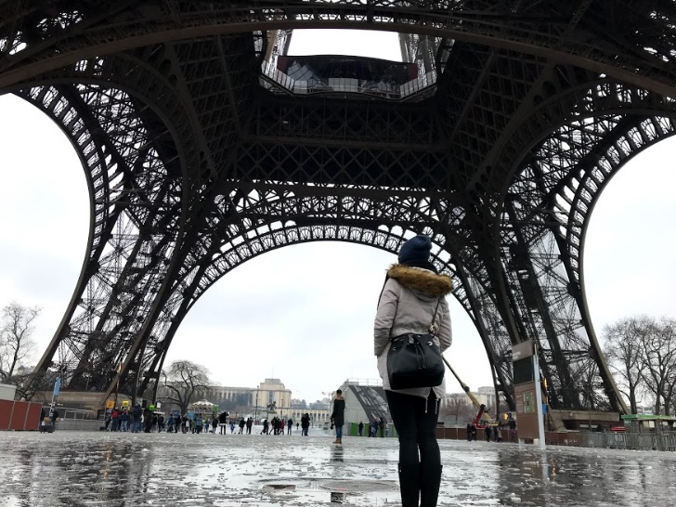
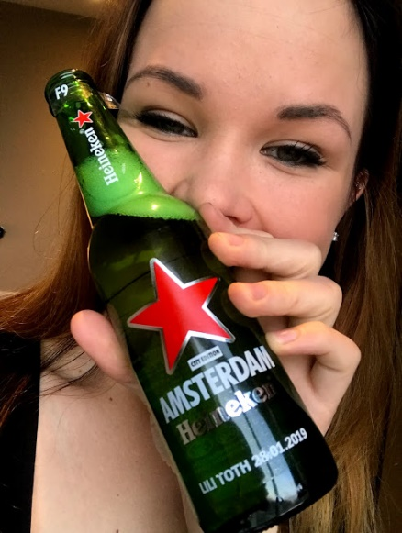
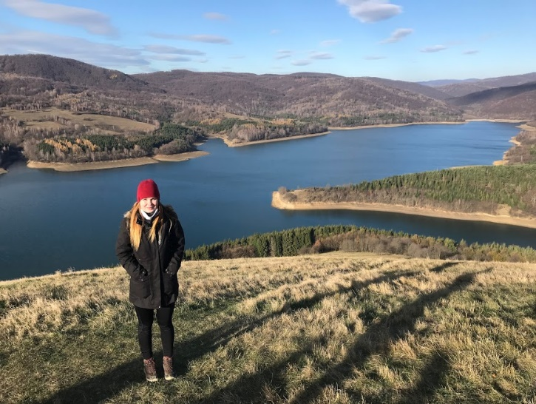

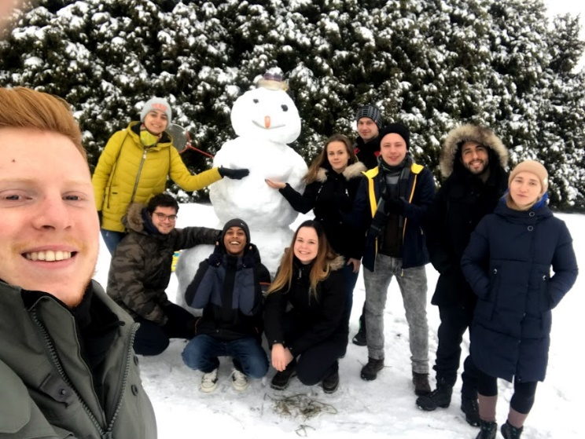
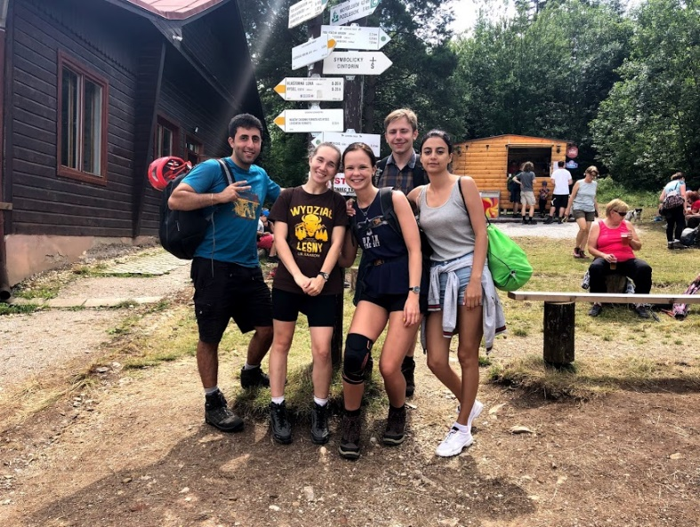
In addition to the numerous opportunities that Erasmus has provided me with, I am most grateful to have met people I see as my second family right now. Each one of them is a great person and has been an integral part of my life since I returned home. To this day, I keep in touch with them regularly, we talk to 2-3 people almost every day and video chat every 1-2 weeks on average. I went back to Krakow for 2.5 weeks in the summer and now I spent another 5 days with them in the fall as well. See you again soon, because just like last year, this year we will celebrate the New Year together in Poland!
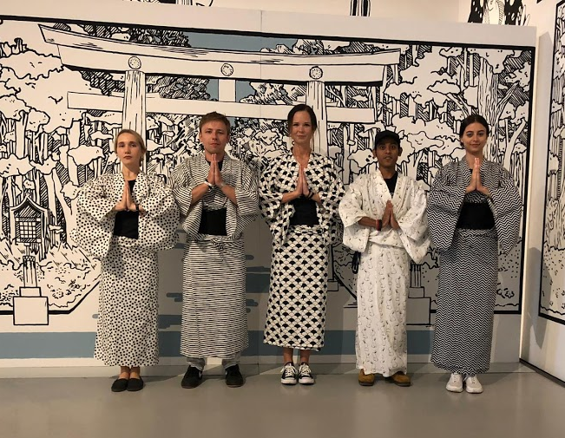

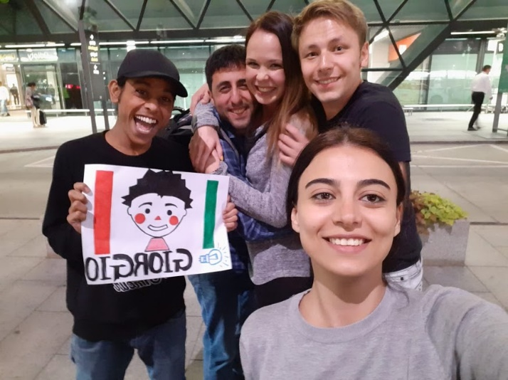
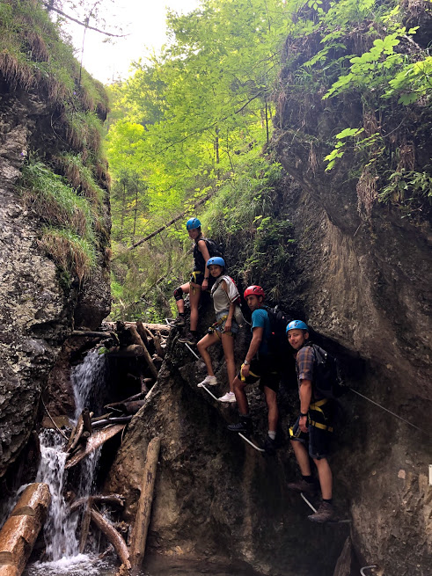
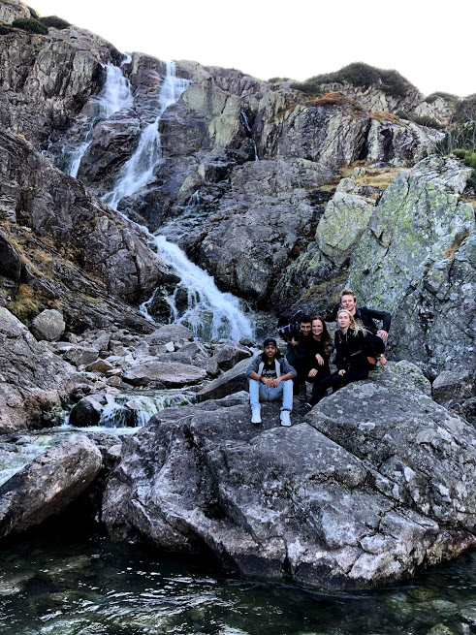
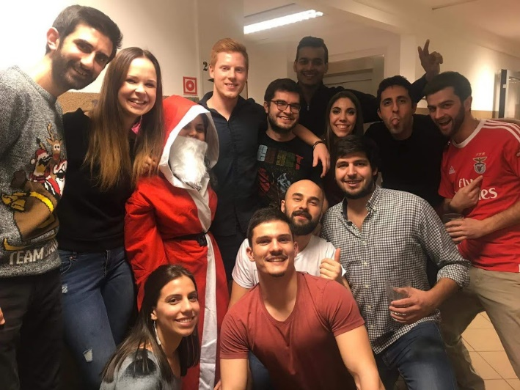
I can say for sure that Erasmus is the best thing that has ever happened to me and that my life has taken a 180 ° turn since my trip. What did the program give me? Memories of a lifetime. Another approach. Experience. Expanded vision. Friends. New life goals. That kind of “I’m richer than ever” feeling (in terms of experiences).
As a result of Erasmus, I applied for the ESN “buddy” program in August (I now have a French mentor here at the University of Debrecen) and am currently applying to Resort Leaders (3 months student work opportunity in America) and want to spend time abroad with Traineshipp next semester. one semester under the Erasmus program.
So anyone who is considering and thinking about participating in the program, go for it! You won't regret it, for sure!

„Travel. As much as you can.
As far as you can. As long as you can.
Life’s not meant to be lived in one place.”

