Prof. Dr. Zoltán Csizmazia

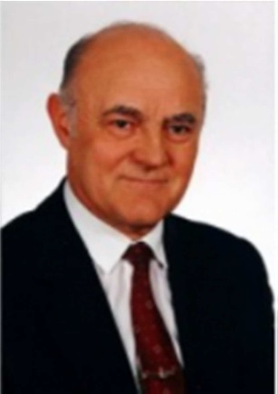

Workplace: University of Debrecen, 4032. Debrecen, Böszörményi u. 138.
Tel: (36) 52-508-443
Fax: (36) 52-508-345
E-mail: Csizmazia@agr.unideb.hu
Education: 1955-1960 certified agricultural mechanical engineer (cert. no.: 3/1960) GATE.

Scientific degree:
1969 PhD
1983 Candidate of Agricultural Sciences

Language skills:

1976 intermediate language exam in German
1995 written intermediate language exam in English
1997 oral intermediate language exam in English

Workplaces and positions:
Agricultural University of Debrecen, Faculty of Agricultural Sciences, Department of Mechanics:
1960-1968 assistant lecturer
1968-1985 senior lecturer
1985-1990 associate professor, head of department
1990- university professor, head of department
1992-1998 university professor, vice rector, head of department
1998-1999 university professor, rector, head of department
University of Debrecen, Centre for Agricultural Sciences, Faculty of Agricultural Sciences, Department of Mechanics:
2000-2001 university professor, prorector, vice rector, head of department
2001-2002 university professor, head of department
2002- university professor, head of Tormay Béla College for Advanced Studies

Higher education activity:

1975- Plant protection machinery
1978- Nutrient management machinery
1985- Nutrient and water management machinery
1985- Agricultural technical basics
1990- Mechanization and architecture of agriculture
1994- Plant protection machinery ( PhD training).
1994- Environmentally friendly mechanization ( PhD training).
2002- Horticultural mechanical engineering

Major research topics:
Automation of plant protection and irrigation in greenhouses. Patent with co-authors 1978.
Three countries granted protection in addition to Hungary.
Establishment of an experimental base for the development of fertilizer spreaders. 1983.
Development of fertilizer spreaders (TORNÁDÓ-5M, 5-TM)
1982, to date, manufactured in series, sold more than
5000 units, (TORNÁDÓ-1300) 1990, (TORNÁDÓ-800) 1992. to date, both machines are manufactured in series.
The most important factors influencing the working width and spreading uniformity of double disc fertilizer spreaders
1983.
Physical characteristics of seeds and fertilizers, development of a material testing laboratory for their testing from 2000.

Scientific public life:
MTA DAB Member of Agricultural Special Committee from 1985.
1988 Managing the machinery exhibition at the international conference IAMFE organized in Hungary (at the Agricultural University of Debrecen).
Member of the Agro-technical Committee of the Hungarian Academy of Sciences from 1990.
Member of the Hungarian Scientific Research Fund – IVth Agricultural Special Committee 1991-1993.
Member of the National Ploughing Competition Committee since 1995, 2003-2008: vice president. Chairman of the Board of Trustees of the Ploughing Competition Foundation: 2005-2008.
Member of the Special Jury of FKFP from 1998. Member of the Agricultural Economics Council: 1998-2000.
Member of the Board of Trustees of the Apáczai Public Foundation: 1999-2005
Member of the Hungarian Scientific Research Fund – IVth Agricultural Special Committee: 2000-2003 and 2005-2007.

2003-2007 President of the Promotional Committee of the Centre for Agricultural Sciences of the University of Debrecen, Vice-president of the Promotional Committee of the Centre for Agricultural Sciences of the University of Debrecen: 2004-2007
2003-tól President of the Promotional Committee of DE AMTC MTK

Honors, recognitions:
Excellent agricultural worker (1969). Excellent worker (1979, 1986).
Badge for trade union work, gold grade
(1988)
Újhelyi Imre prize (1992).
Pro Universitate-prize (1997, 2001). Academy prize (2001).
Commemorative Medal for Agricultural Higher Education in Debrecen (2003) Az év oktatója díj (2003)
Pro Facultate prize (2003)
Officer's Cross of the Order of Merit of the Republic of Hungary (2003)
Hatvani prize (2006)

19th January 2009, Debrecen

Dr. Zoltán Csizmazia
university professor

