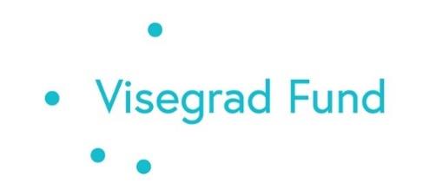

SPRING SCHOOL IN POLAND, 22—28 April, 2024
University of Agriculture in Krakow

APPLICATION FORM

Please, download the file, fill in electronically, and send to the e-mail of your national contact given on the project website https://mek.unideb.hu/en/node/1653.

Disclaimer: The personal information you provide in this application form will be used solely for the purpose of communication with you in relation to the activities of the Visegrad Grant project #22320101. We will only collect and retain the minimum amount of personal data necessary to fulfill this purpose.
Your name:

University:

Course name:  Level (please underline): |  | BA/MA
Semester you are completing:
Native language:

Level of English language knowledge:  (please, underline) | beginner  pre-intermediate  intermediate  upper-intermediate  advanced
Favorite subjects (1-3):

Your expectations regarding the summer school:
Your e-mail address:

The project is co-financed by the Governments of the Czechia, Hungary, Poland and Slovakia through Visegrad Grants from International Visegrad Fund. The mission of the fund is to advance
ideas for sustainable regional cooperation in Central Europe.

